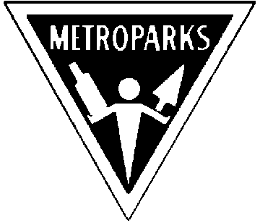Kensington Metropark Seventh Annual
Astronomy at the Beach Sept. 5th & 6th
(Time: 5:00 pm to Midnight rain or shine)

Great Lakes Association of Astronomy Clubs

http://www-personal.umich.edu/~dgs/kensington/

See Mars at it’s Closest To Earth In Over 57,000 Years!!

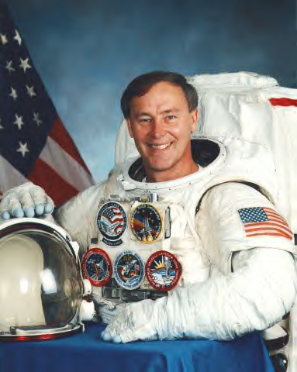
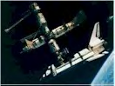
View Mars and Dozens of Other Exciting Objects Through Our Telescopes and Binoculars
Special Guest Speaker

NASA Astronaut Jerry Ross
Sponsored by
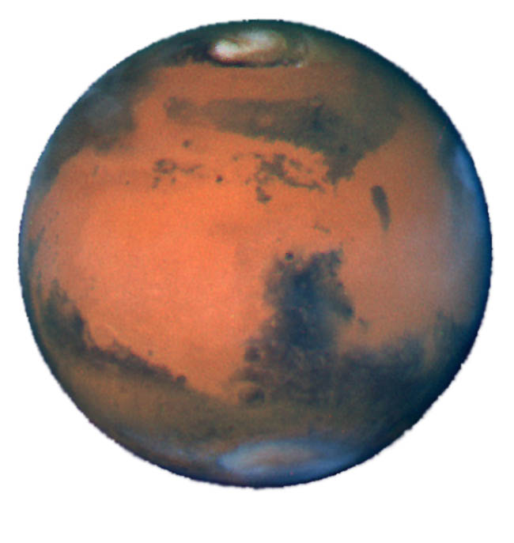
- Ford Amateur Astronomy Club
- Warren Astronomical Society
- Eastern Michigan University Astronomy Club
- University Lowbrow Astronomers (Saturday night)
- Oakland Astronomy Club)
- Seven Ponds Astronomy Club
- Sunset Astronomical Society
- Genesee Astronomical Society Rider’s Hobby Shops

- Amateur Astronomers of Jackson
For astronomy club information
Visit the GLAAC web page at: http://www.boonhill.net/glaac/
See the Skies through our Equipment or Bring your Own!

Bring your family, students, teachers & scouts!!!

- Learn Astronomy - Slide Presentation - Comet making Demonstration! - View Sun Spots
- Take a Tour of the Constellations - CCD digital Imaging
- Learn How to Choose & Use Telescopes - Sky tour Treasure Hunt
- Food and Beverages (available for purchase)

Kensington Metropark I-96 at the Kent Lake Road exit (153).
Go North to Martindale Beach. Phone 1-800-477-3178
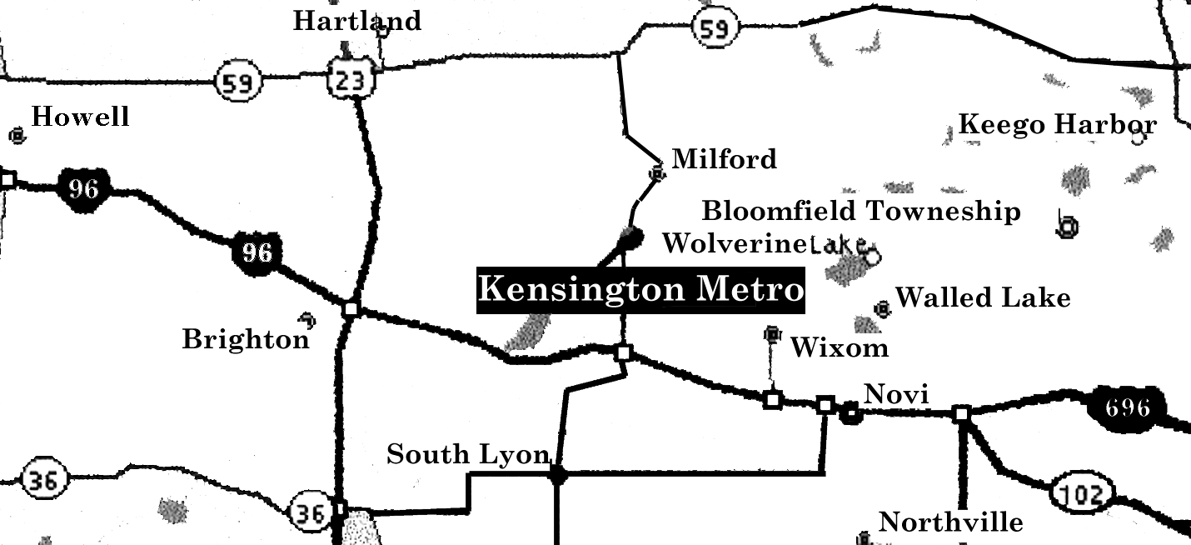
This Event is FREE!

$4.00 Park Vehicle Permit Required
Revised 7/13/2003

