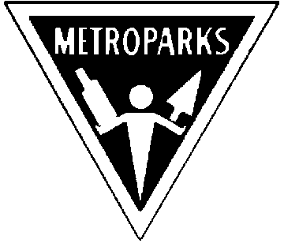Kensington Metropark Ninth Annual
Astronomy at the Beach Sept 9th & 10th
(Time: 5:00 pm to Midnight rain or shine)

Great Lakes Association of Astronomy Clubs

http://www-personal.umich.edu/~dgs/kensington/

Explore Your Universe

View Dozens of Exciting Objects through Our Telescopes and Binoculars

Special Guest Speakers

(Friday) JPL Solar System Ambassadors Shannon Murphy &
John Schroer discussing “Exploring Your Solar System”.

(Saturday) Dr. Fred Adams “Into the Dark - The Long Term Future of Our Dying Universe”
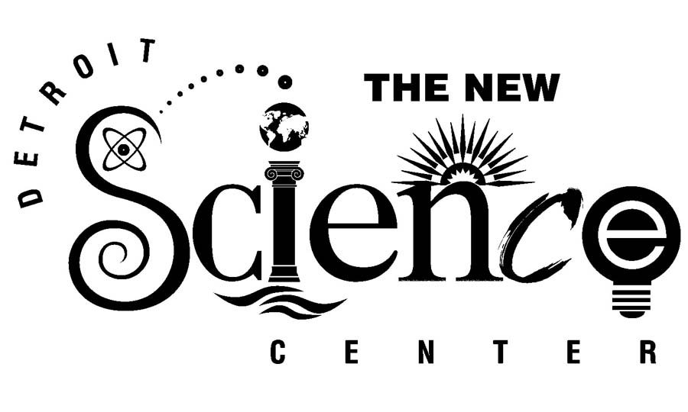
Sponsored by:
- Ford Amateur Astronomy Club
- Warren Astronomical Society
- Eastern Michigan University Astronomy Club
- University Lowbrow Astronomers
- Oakland Astronomy Club
- Seven Ponds Astronomy Club Riders Hobby Shops

- Sunset Astronomical Society
- Amateur Astronomers of Jackson
Visit the GLAAC web page at: http://www.boonhill.net/glaac/
See the Skies through our Equipment or Bring your Own!

Fun for families, students, teachers & scouts!!! Learn about astronomy first hand.

- Comet Making Demonstration! - How Cold Is Space? - View Sun Spots - See Digital Imaging
- Tour the Constellations - Take a Sky Tour Treasure Hunt
- How to Choose & Use Telescopes

- Food and Beverages (available for purchase) - Bring a Chair or Blanket
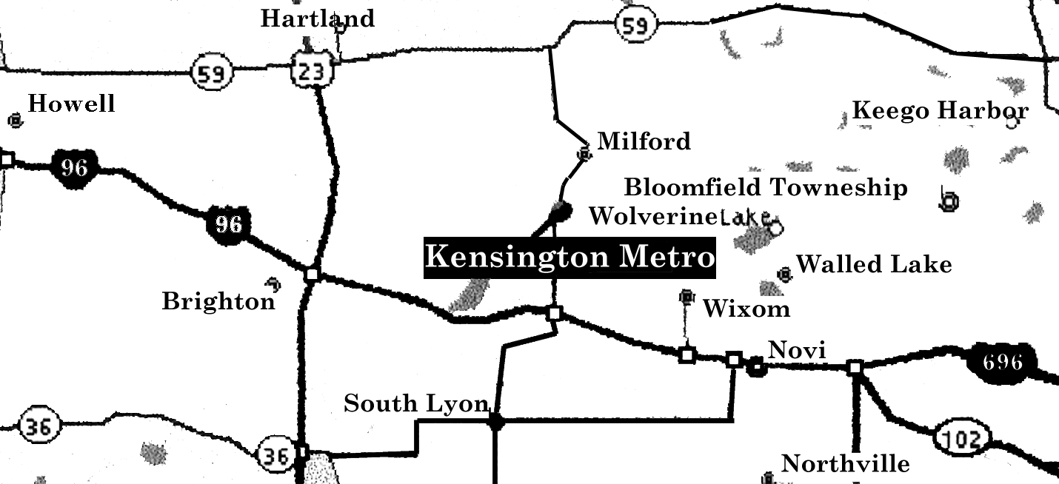
Kensington Metropark I-96 at the Kent Lake Road Exit 153 North
Go North to Martindale Beach.
Phone 1-800-477-3178
This Event is FREE!
$4.00 Park Vehicle Pass Required
Revised 7/22/2005

