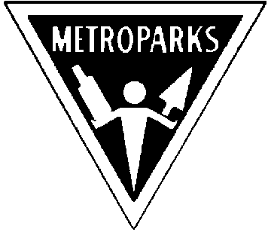Kensington “Summer Star Gaze”

June 2nd & 3rd(Time: 6:00 pm to Midnight )
Sponsored by the

Great Lakes Association of Astronomy Clubs

(weather permitting, call hotline for further info (313) 577-8400 ext 475)

Explore Your Universe
View Dozens of Exciting Objects through our telescopes and Binoculars

Beginners Telescope Workshop

1.) Amateur Astronomers welcome to explore the skies on the beach.
2.) Beginners bring your telescope, your questions and set up an appointment to work with an amateur astronomer at the telescope workshop. (Call the telescope hotline at (313) 577-8400 ext 475 to set an appointment.)
3.) Food and Beverages (available for purchase)


Sponsored by:
- Ford Amateur Astronomy Club
- Warren Astronomical Society
- Astronomy Club at Eastern Michigan University

- University Lowbrow Astronomers
- Oakland Astronomy Club
- Seven Ponds Astronomy Club
- Sunset Astronomical Society
- Amateur Astronomers of Jackson

Visit the GLAAC web page at: http://www.boonhill.net/glaac/ Riders Hobby Shops

Don’t forget
Kensington Metropark tenth Annual
Astronomy at the Beach coming in September
http://www-personal.umich.edu/~dgs/kensington/

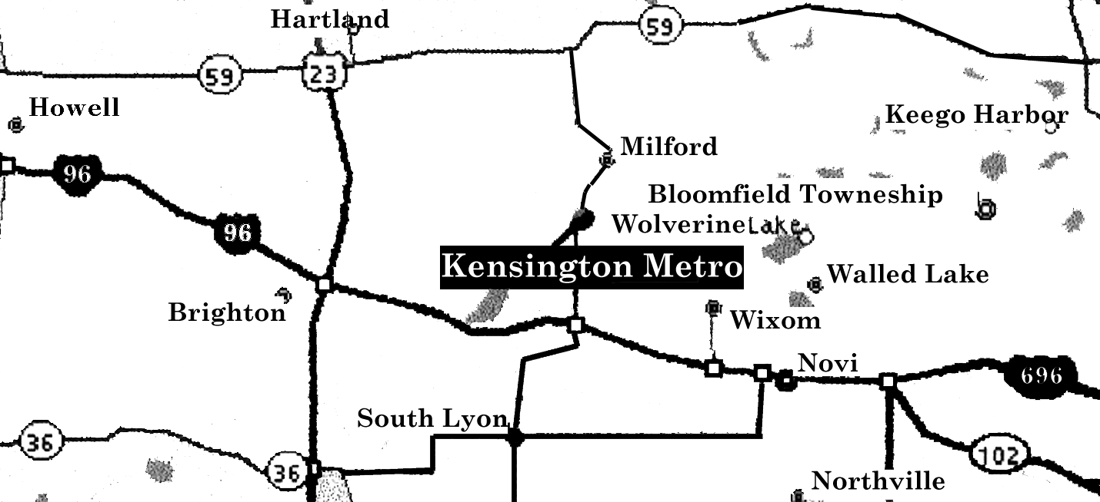
Kensington Metropark I-96 at the Kent Lake Road Exit 153 North
Go North to Martindale Beach.
Phone 1-800-477-3178
This Event is FREE!
$4.00 Park Vehicle Pass Required
Revised 4/16/2006

